**How to run a flask-based object detection application**

1. ***With docker compose (both images: flask and TensorFlow serving)***

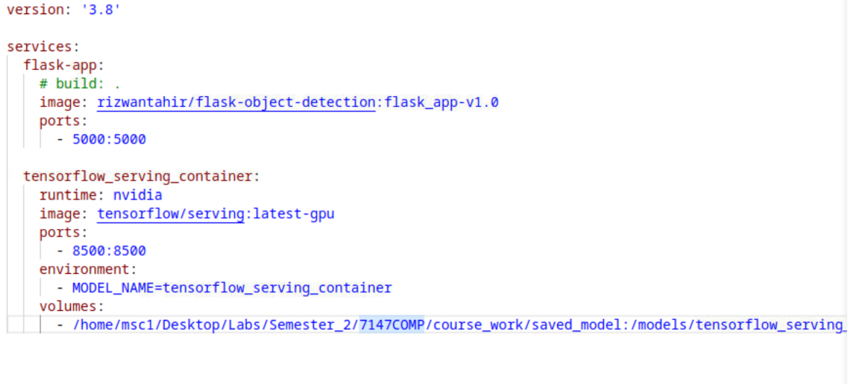

* Extract the file1.zip file in any directory.
* Go to the root directory where you can see FlaskObjectDetection, saved_model, Dockerfile and docker-compose.yml.
* In “**docker-compose.yml**” file make sure your path for save_model is correct. This will be according to your directory structure from the root of your machine. In my case it is “/home/msc1/Desktop/Labs/Semester_2/7147COMP/course_work/saved_model”:/models/tensorflow_serving_container
* Run cmd here.
* Make sure you have installed docker on your system by running this command “sudo docker version”
* Run “sudo docker-compose up” command to access flask-based object detection application.
* Go to chrome browser and hit “http://localhost:5000”
* Run “sudo docker-compose down” to stop the application.

***2- With docker compose (one image: TensorFlow serving, one build: flask)***

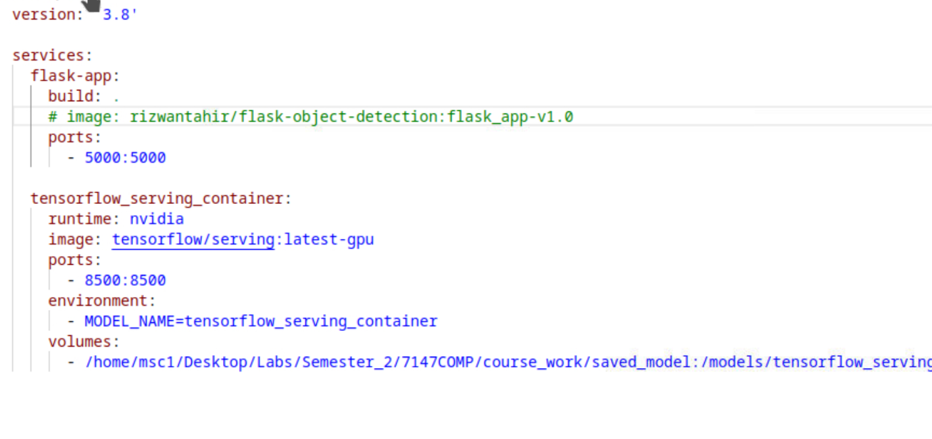

* Extract the file1.zip file in any directory.
* Go to the root directory where you can see FlaskObjectDetection, saved_model, Dockerfile and docker-compose.yml.
* In “**docker-compose.yml**” file make sure your path for save_model is correct. This will be according to your directory structure from the root of your machine. In my case it is “/home/msc1/Desktop/Labs/Semester_2/7147COMP/course_work/saved_model”:/models/tensorflow_serving_container
* Run cmd here.
* Make sure you have installed docker on your system by running this command “sudo docker version”
* Run “ sudo docker-compose build –no-cache”
* Run “sudo docker-compose up” command to access flask-based object detection application.
* Go to chrome browser and hit “http://localhost:5000”
* Run “sudo docker-compose down” to stop the application.

**Docker commands**

Docker command to build container

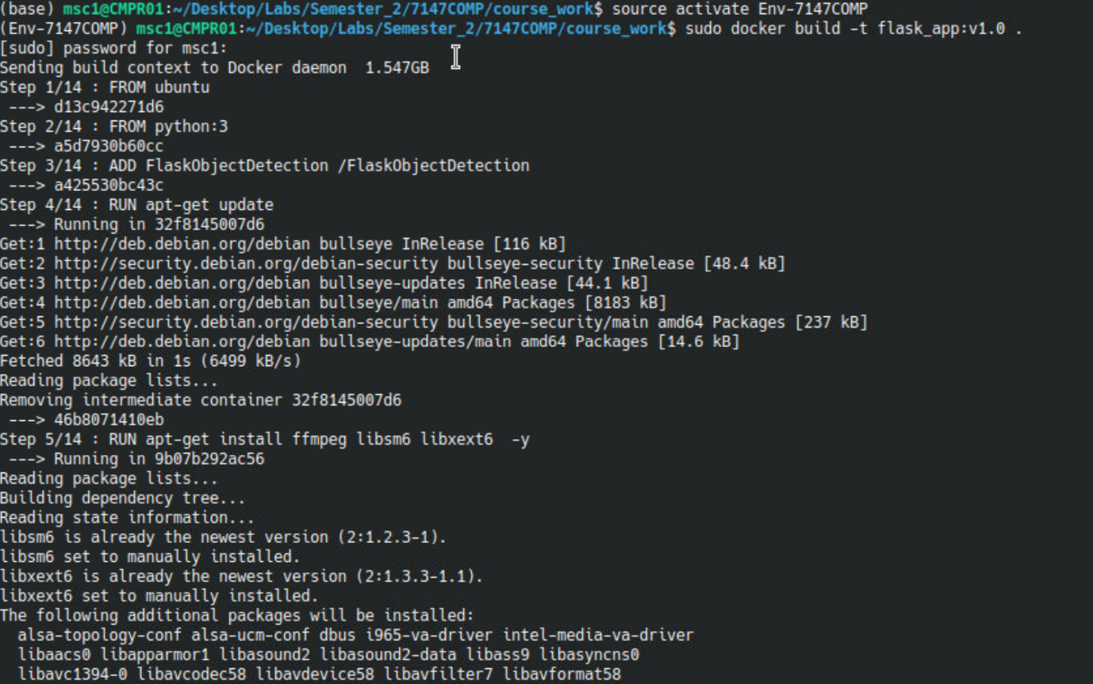

Docker command to run container

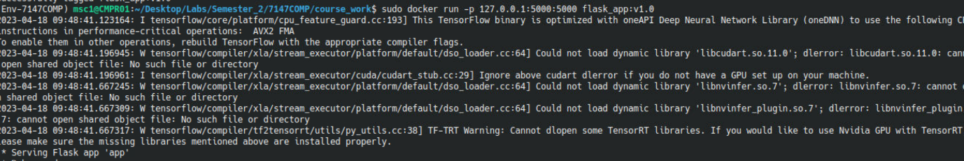

Docker command to see the list of containers with their name and status

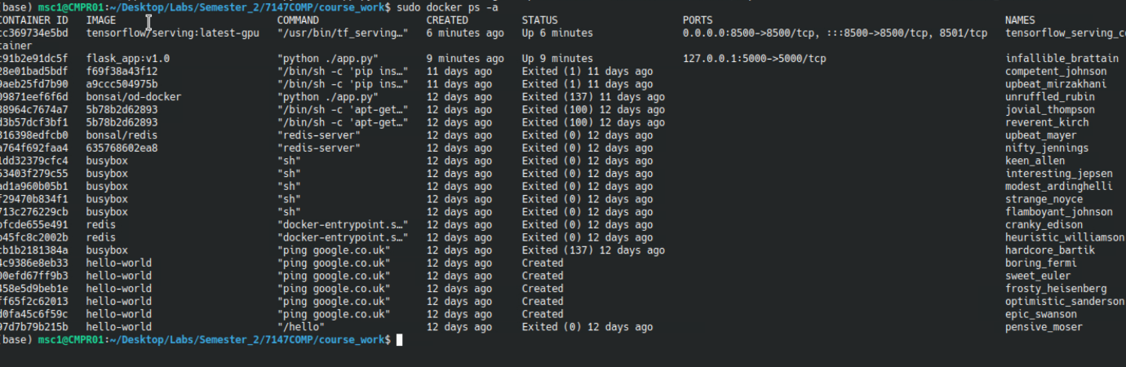

Docker command is used to stop container



Docker command is used to remove/delete container



Docker command is used to run a Docker container for TensorFlow serving with GPU support

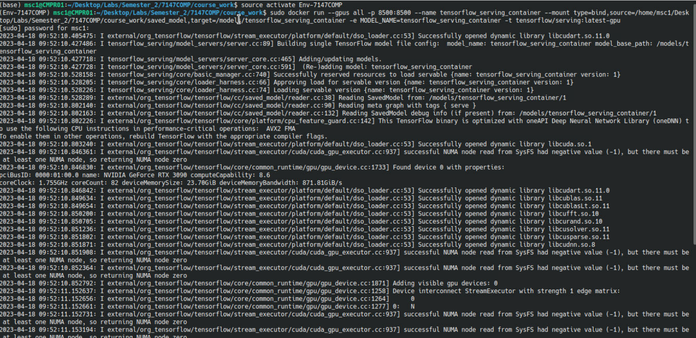

**Docker Compose Commands**

Docker compose command to build image

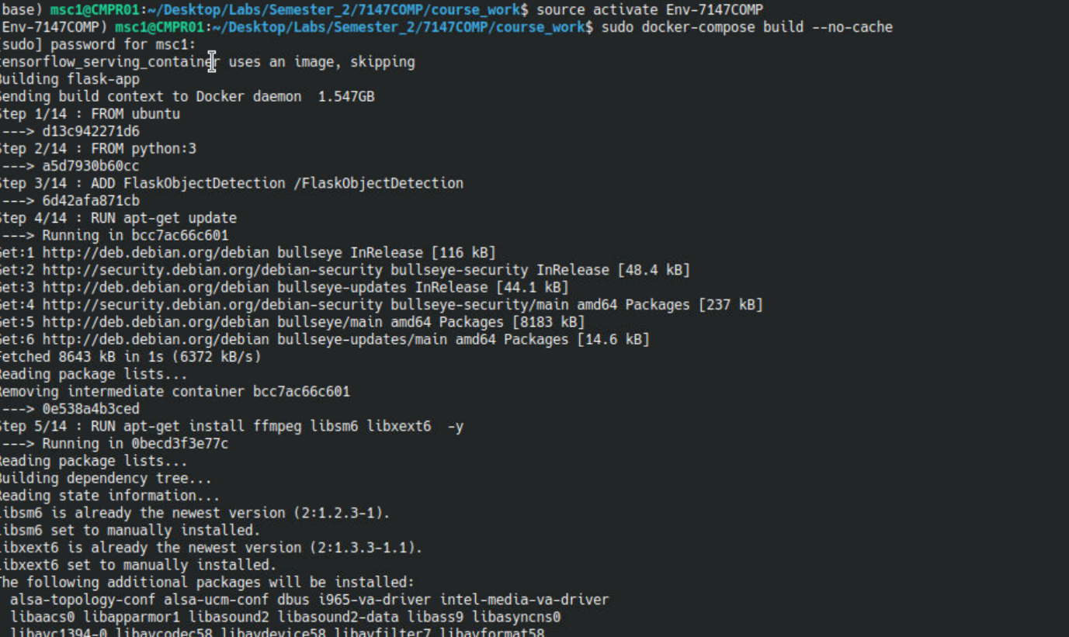

Docker compose command to run containers

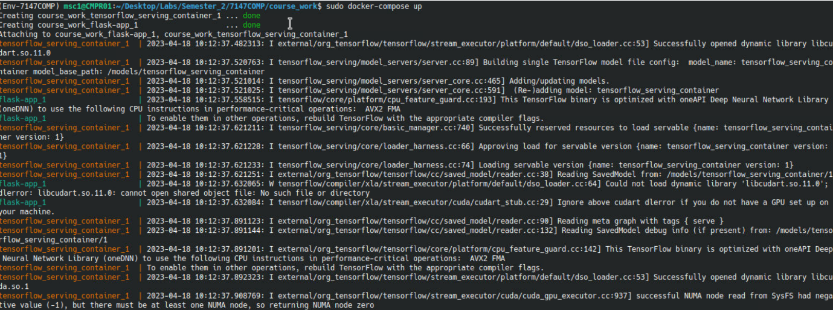

Docker compose command to stop containers

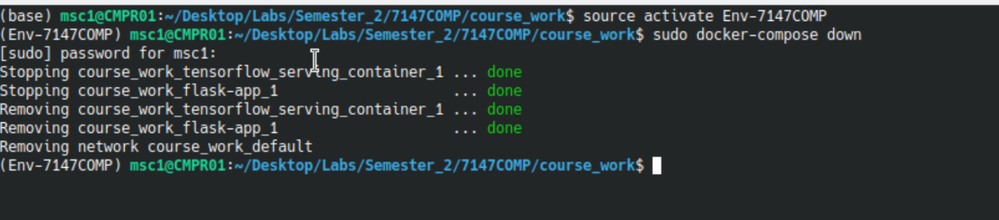

**(If in docker compose yml file we set all the docker images for services than we just need to run “sudo docker-compose up”)**

**Docker Hub**

Tag local image to docker hub repository



Push local image to docker hub repository



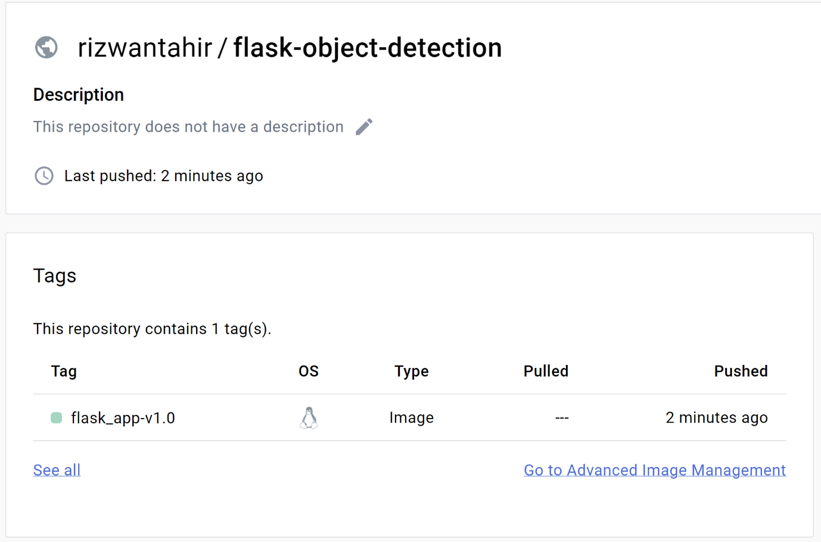

**Github (For Code Management)**

**Github clone :** [**https://github.com/rizwantahir786/flask-object-detection.git**](https://github.com/rizwantahir786/flask-object-detection.git)

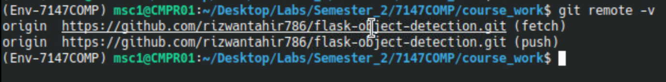

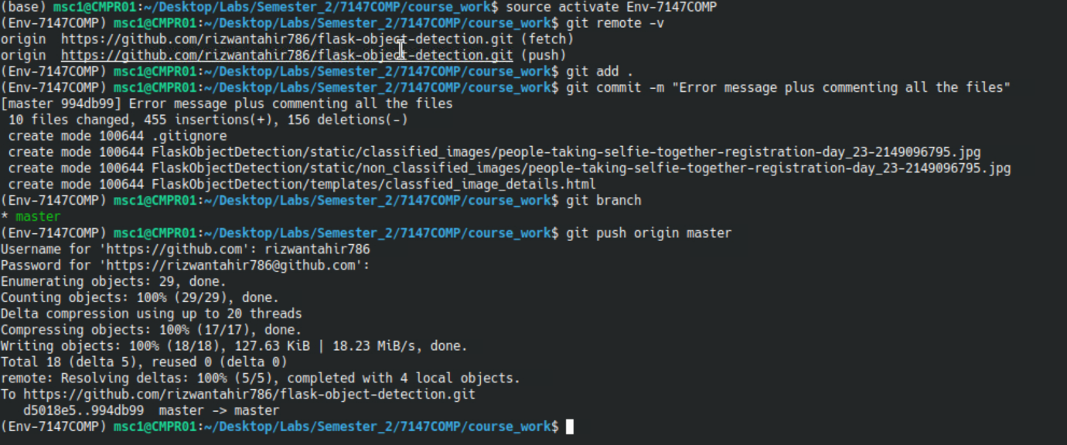

**Application Screenshots**

Index.html

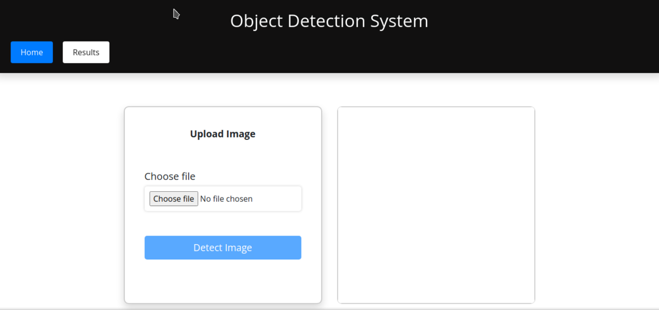

Results.html (when firebase collection is empty)

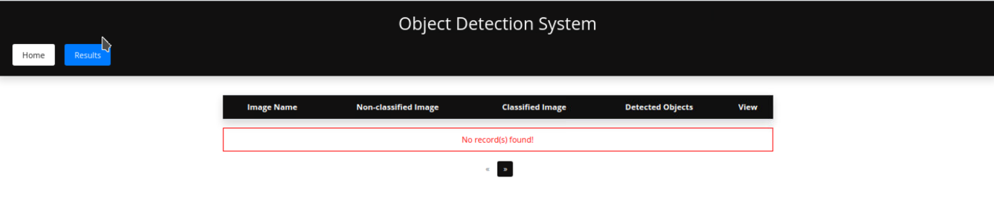

Classified_image_details.html

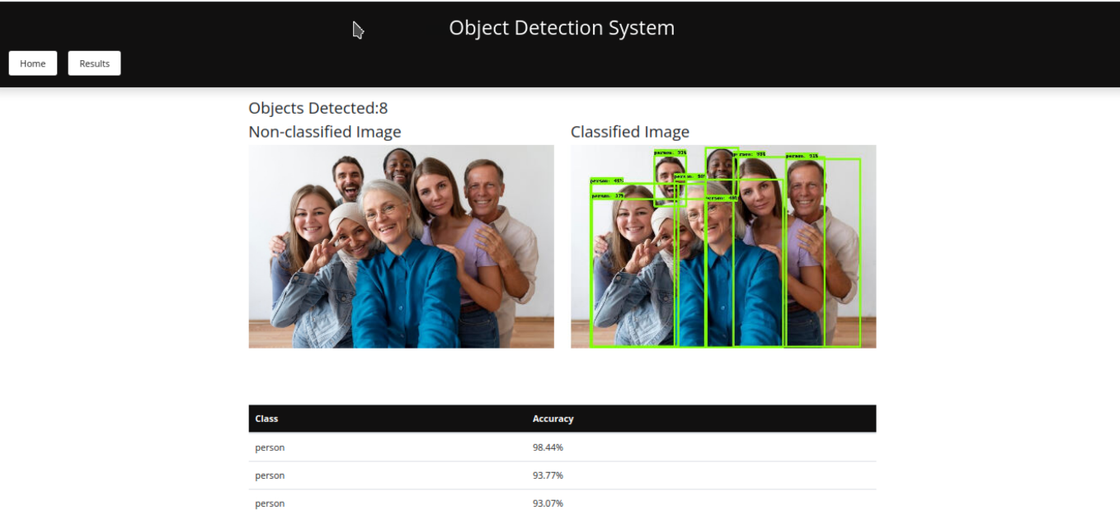

Results.html (When user will clicks on view details of specific image)

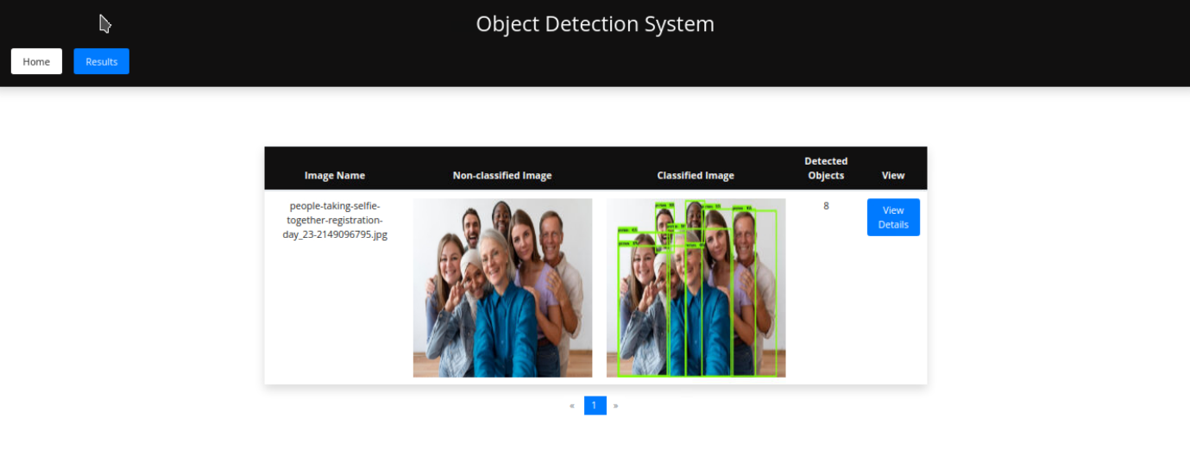

Result.html (When user will clicks on view details of specific image)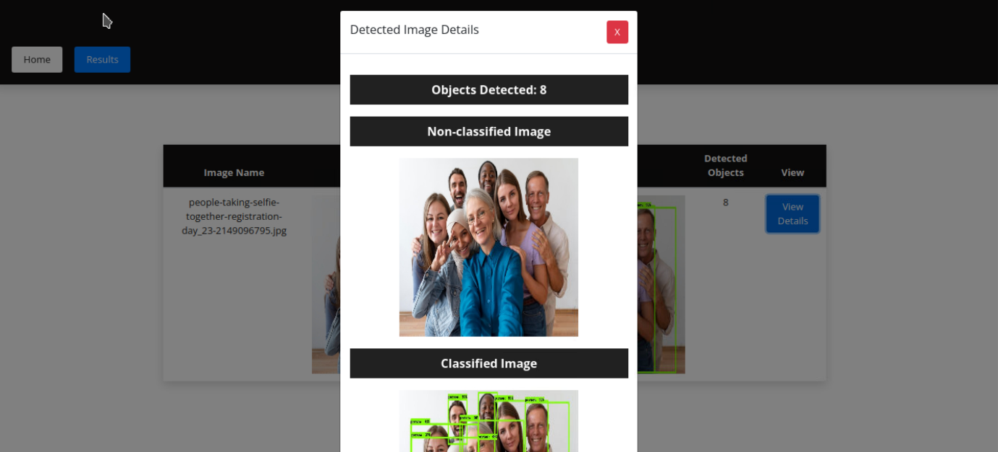

Firebase Dashboard (It shows that one document has been stored against results collection)

